Nuclear Chemistry

A study of the nuclear changes in atoms is termed Nuclear Chemistry.

RADIOACTIVITY
The elements whose atomic nucleus emits radiation are said to be radioactive. The spontaneous breaking down of the unstable atoms is termed radioactive disintegration or radioactive decay. The disintegration or decay of unstable atoms accompanied by emission of radiation is called Radioactivity.

TYPES OF RADIATIONS
The radioactive radiations are of three types. These were sorted out by Rutherford (1902) by passing them between two oppositely charged plates (Fig. 4.1). The one bending towards the negative plate carried positive charge and were named α (alpha) rays. Those bending towards the positive plate and carrying negative charge were called β (beta) rays. The third type of radiation, being uncharged, passed straight through the electric field and were named γ (gamma) rays. α, β and γ rays could be easily detected as they cause luminescence on the zinc sulphide screen placed in their path.

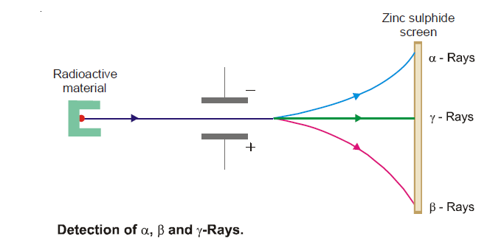

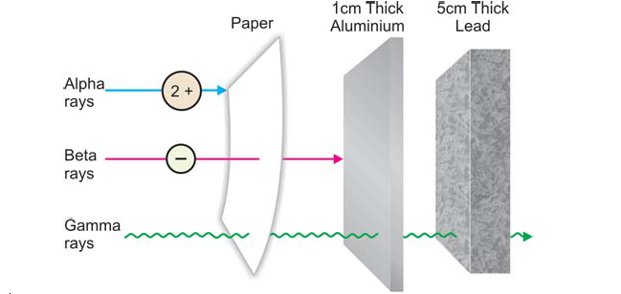
NUCLEAR REACTIONS
A nuclear reaction is one which proceeds with a change in the composition of the nucleus so as to produce an atom of a new element.
The conversion of one element to another by a nuclear change is called transmutation.

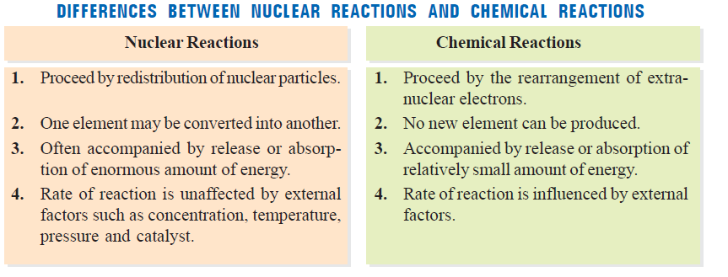

NUCLEAR FISSION REACTIONS
In these reactions an atomic nucleus is broken or fissioned into two or more fragments.

For example
, 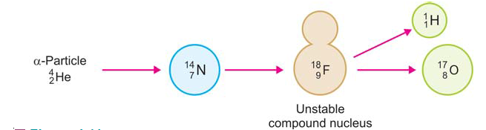

NUCLEAR FUSION REACTIONS
These reactions take place by combination or fusion of two small nuclei into a larger nucleus.
For example :